 |  |  |  | 33. | 100 |  | Induction plate single
 |  | OFFER |  | 34. | 100 |  | Pan set 3 pieces
 |  | HOUSEHOLD MIX
 |  | HOUSEHOLD MIX |  | 38. | 173 |  | STEAK KNIFE SET 12
 |  |  |  | 39.
.Pos. | Quantity | Type/Articles |  | 39. | 200 |  | CUTLERY SET 24 PIECES
 |  |  |  | 40.
1. | 200 | TV 65 INCH |  | 40. | 20 |  | FAN
2. | 200 | TV 55 INCH |  | 41. | 200 |  | SINGLE HOTPLATE
3. | 200 | TV 40 INCH |  | 42. | 200 |  | DOUBLE HOTPLATE
4. | 200 | TV 32 INCH |  | 43. | 50 |  | PRESSURE PAN
 |  |  |  | 44.
5. | 300 | OVEN 32/48 L |  | 44. | 120 |  | POT WITH LID
6. | 300 | OVEN 52 L/60L |  | 45. | 120 |  | DISHWASHER SET 50
 |  |  |  |  |  |  | PIECES
7. | 300 | POT SET 16 PIECES
7. | 300 | POT SET 16 PIECES |  | 46. | 300 |  | TOASTER
8. | 1000 | FRUIT MIXER PLASTIC
8. | 1000 | FRUIT MIXER PLASTIC |  | 47. | 28 |  | GENERATORS
9. | 500 | FRUIT MIXER GLASS
9. | 500 | FRUIT MIXER GLASS |  |  |  |  | Home&Kitchen Ware
 |  |  |  | 48. | 80.000 |  | Mix with listing,Electric
10. | 200 | JUICER
10. | 200 | JUICER |  |  |  |  | and Non electric
11. | 300 | CONTACT GRILL |  |  |  |  | Soon the new arrive will
12. | 300 | ELECTRIC GRILL |  |  |  |  | copmplite
 |  |  |  | 49. | 50.000 set |  | FRUIT KNIFE 2/4/5
13. | 100 | GRILL PLATE RACLETTE
13. | 100 | GRILL PLATE RACLETTE |  |  |  |  | PIECES
 |  |  | .Brand :
14. | 300 | POT SET 9 PIECES
 |  |  |  | SCHEFFLER,
15. | 300 | POT SET 12 PIECES
15. | 300 | POT SET 12 PIECES |  | HOMELUX,
16. | 300 | POT SET 8 PIECES
16. | 300 | POT SET 8 PIECES |  | EISENBACH,
17. | 800 | FRYER 2.5 L |  | LENTZ
18. | 200 | FRYER 3.5 L |  | LANZOO,
 |  |  |  | MICHELINO,
19. | 500 | DOUGH MACHINE/
19. | 500 | kitchen machine |  | SCHAEFER ,
20. | 500 | KITCHEN MACHINE 3/1 |  | REHINSTAHL
 |  |  |  | WALTERSTAHL,
21. | 300 | FRYER NEW MODEL
 |  |  |  | HOFFMANNS,
22. | 4000 | Water cooker/ kettle
 |  |  |  | BOSENBERG
23. | 200 | Multi chopper
24. | 500 | Multi pan electric
25. | 500 | Trash can 30 l
26. | 500 | Trash can set 2 pcs
27. | 500 | GAS HOB 4
28. | 500 | GAS HOB 2
29. | 500 | STEAM IRON
30. | 100 | deep FRYER
31. | 300 | VACUUM CLEANER
32. | 100 | Induction Hotplate double

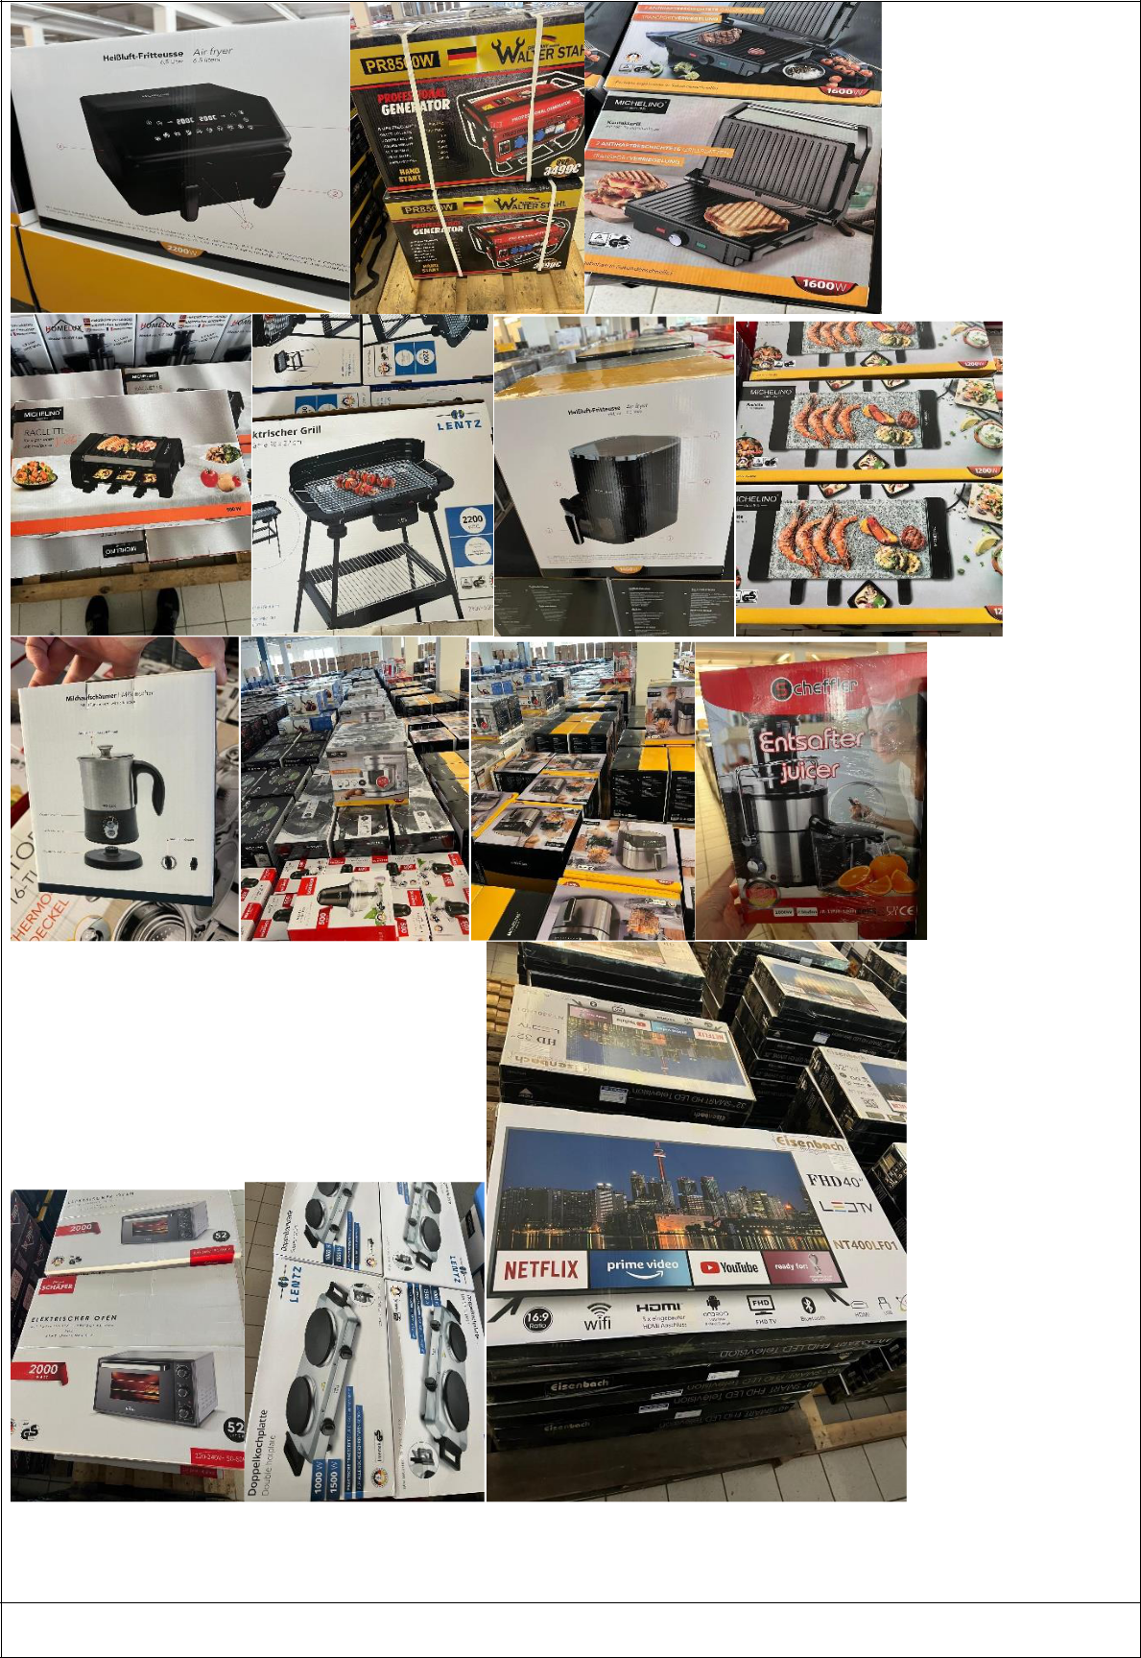

Type/Articles

TOTAL: 146.611 Pieces

Brand : SCHEFFLER, HOMELUX, EISENBACH, LENTZ LANZOO, MICHELINO, SCHAEFER , WALTERSTAHL, HOFFMANNS, BOSENBERG, REHINSTAHL

